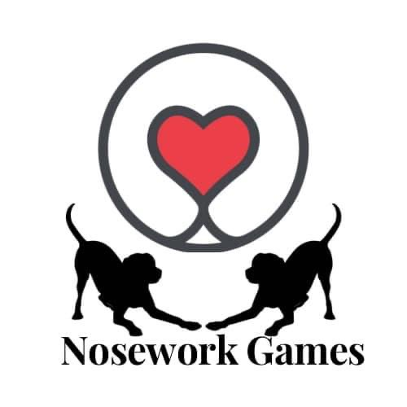

On the Way Up Skills Assessment Log

 | Game | Assessor | Organiser
1
2
3
4
5
6
7
8
When you have completed skill Assessments on 8 different Level 2 games you are a Nosework Games On the Way Up Skills Team.
Please contact marie.poole@me.com to claim your certificate and rosette if desired.

