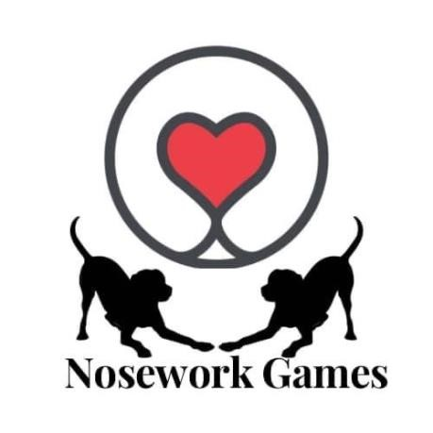

*Nosework Games are proud to certify that*

**-------------------------------**

*Have attained the title of*

**Nosework Games**

**Snake**

**Newbie Skills Award**

**Learning Through Play**